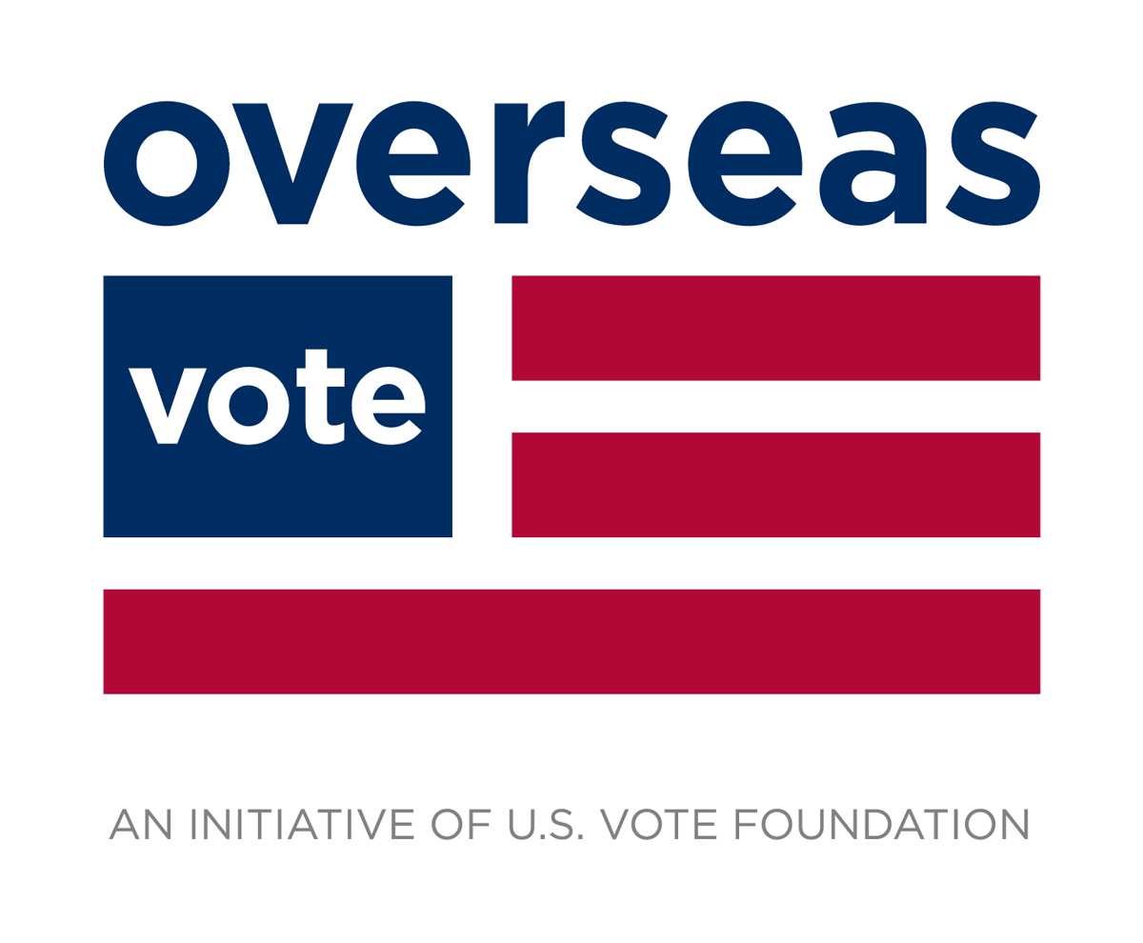

**Dear Overseas Voter,**Thank you for using the Overseas Vote site to generate your Voter Registration/Ballot Request form.

Please follow these steps to complete the ballot request process:

**1. Check your form:**

**Verify your information**.

* If changes are needed, return to the Overseas Vote website, www.overseasvote.org, to correct and download a new form.
* If any information is missing from your form, for example, an unchecked box, you can mark it by hand.

**2. Print and sign your form:**

Sign your form and addendum page. Your election official requires your ***ORIGINAL SIGNATURE***.

**3. Address your envelope to your local election office:**

**4. Send in your Signed, Dated Original Form:**

**Postal Mail:** Overseas Vote recommends regular postal mail as the most secure method for transmitting your confidential election materials to your local election office.

Mail your form from a post office, if possible, and have the envelope legibly postmarked with the mailing date.

**Other Transmission Options:** Some states allow you to fax or email the form to speed processing. You can find all of the Voter Materials Transmission Options for your state on the Overseas Vote website under State Voting Requirements.

**5. Confirm that you are on the voter rolls and will receive your ballots.**

We recommend that you contact your local election official after sending in your ballot request form to confirm that it has been received and approved.

**Overseas Voting Contact:**

**Local Election Official:**

Never assume that your ballot will simply arrive for the next election. Contact your election office and avoid surprises.

***Am I Registered?***  Consult the State Lookup Tools in the State Voting Requirements section of our website for your state's voter registration confirmation service.

**6. Mark Your Calendar and Be Prepared to Use a Back-Up Ballot**

Sometimes ballots arrive late. If you haven't received your official ballot from your local election office **30 days** before the election, return to the Overseas Vote website and use the Federal Write-In Absentee Ballot option.

**7.** [**Please give back**](https://www.usvotefoundation.org/donate) **to US Vote and Overseas Vote and Help Us to Help More Voters:**

**We work hard to make sure that you can vote. And when you give to us, you can be sure – Every Dollar Counts. And your voting effort goes further.**

### $1 x 1 helps assure another voter gets their ballot. $1/month has 12 times the impact. $3/month has 36 times the impact. $10/month has 120 times the impact every year!

### **Please Join Us as a Foundation Member - a small monthly contribution will make a major difference – it will change everything about what we can do for you and other voters. Go to** www.usvotefoundation.org/donate

**Thank you!**

[**Get your Overseas Voter Reward Badge**](https://www.usvotefoundation.org/voter-reward-badge)**!**

Choose from a selection of Overseas Voter Reward Badges - spiff up your social media profile and spread the word to other voters! Go here to get your badge: https://www.usvotefoundation.org/voter-reward-badge

We wish you a positive voting experience in the coming election,

**The Overseas Vote Team**  
http://www.overseasvote.org

P.S. [Donate now and make your contribution monthly](https://www.usvotefoundation.org/donate) **-** It is how we will be able to continue to work every day to make sure that **Every Citizen is a Voter**.

**About Us**

**U.S. Vote Foundation** (US Vote) is a nonpartisan, not-for-profit, civic tech development organization with a crystal-clear mission, **Every Citizen is a Voter**. Our goal is to enable every US citizen to influence the leadership of their communities and country through the power of their vote.

Our **Overseas Vote** initiative reaches US citizens around the world - each of which carries their right to vote with them where ever they may be.

Our Foundation receives no grants: **We rely on membership and donations**. There is always another election around the corner and our development work never stops. Even the smallest contributions go a long way.

Dear Voter,

Double-check the form on the next page. We tried to pre-fill it for you, based on what you’ve told us, but it doesn't always come out right.

If you find something missing, like an unchecked box, use your pen to correct it by hand. And remember to sign the form.

We’re constantly working on improving our service to U.S. voters. If you want to give us feedback, we invite you to contact us at [voterhelpdesk@usvotefoundation.org](mailto:voterhelpdesk@usvotefoundation.org).

*Happy Voting!*